Welcome to the thingSoC® I2C Hub
The TSOC_GROVEY_I2CHUB is an I2C Switch/Hub, based on the NXP PCA9546A chip, in an Embedded Module format for the new thingSoC, Internet of Things open source hardware standard.
Getting Started :
The TSOC_GROVEY_I2CHUB provides four (4) high speed I2C ports for four independent I2C channels. While you could just "daisy-chain" four (4) I2C connections, there are several situations that require a "hub", including :
- When you need to do 3.3 Volt to 5.0 Volt level conversion.
- When you have several I2C peripherals that use the same I2C address and you cna't change the addess. The "hub" allows you to select between them.
- When you want to limit the capacitance of each I2C bus segment. This allows you to run the I2C bus faster than daisy-chaining would allow.
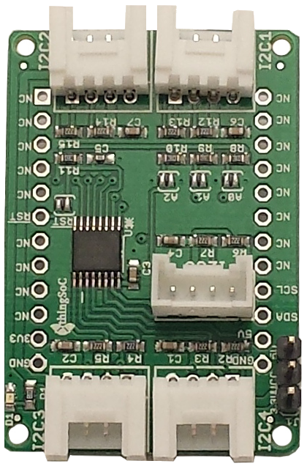
The TSOC_GROVEY_I2CHUB is an open source hardware project from PatternAgents, LLC,
and you are free to download the schematics, layouts, gerbers, BOMs, etc and build your own boards if you wish.

Safe Handling Precautions :
1) Always remove/unplug all power before inserting or removing peripherals.
2) Always ground yourself by touching a ground point before handling your boards.
3) Use a static safe bag when transporting your TSOC_GROVEY_I2CHUB board.
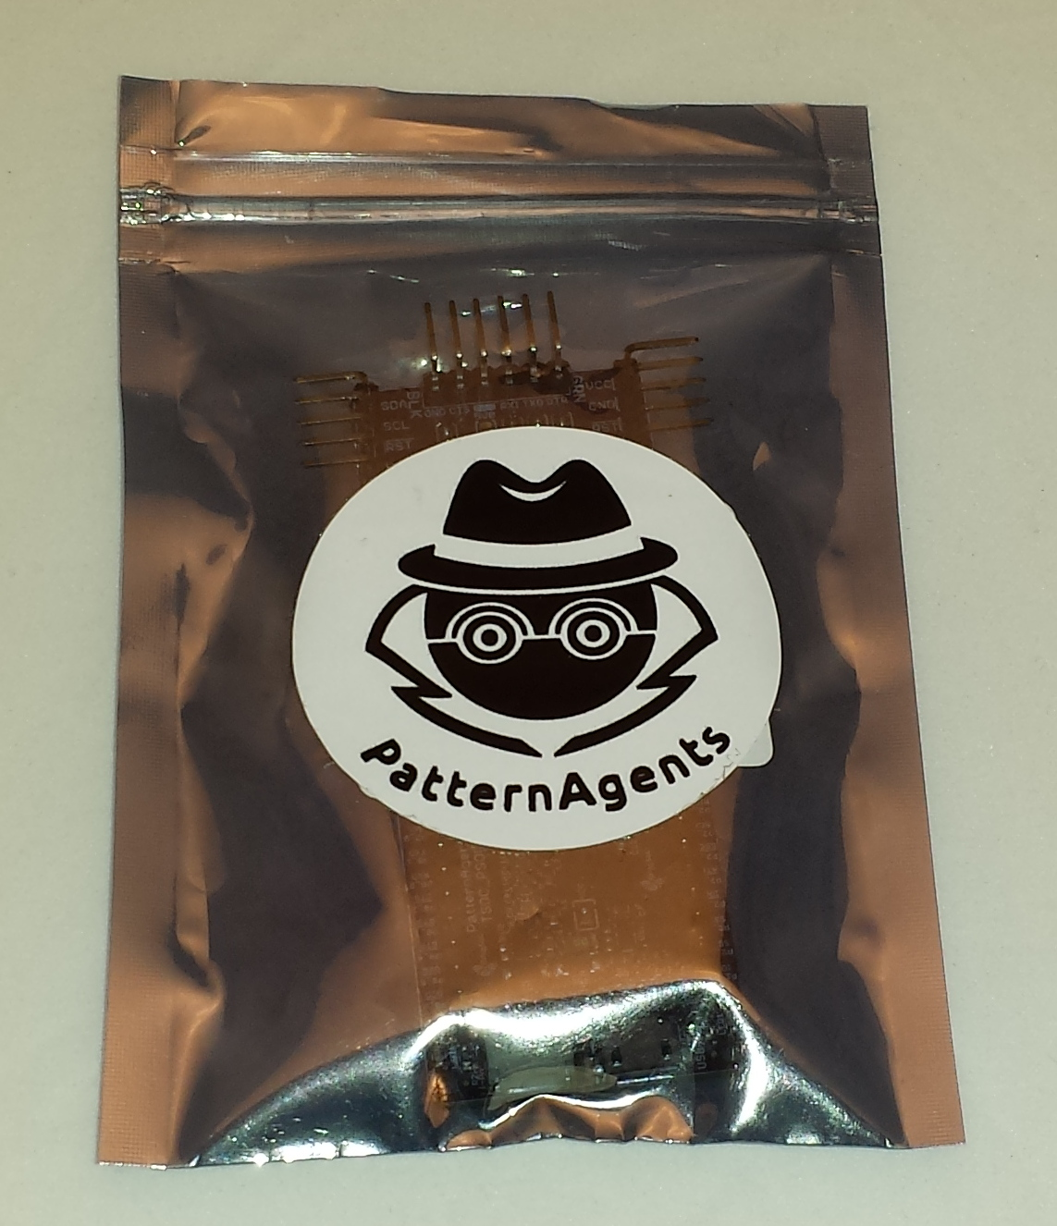

Adding Grove Peripherals :
The TSOC_GROVEY_I2CHUB board supports Grove peripherals.
1) Grove connectors are polarized, and can only be plugged in one way.
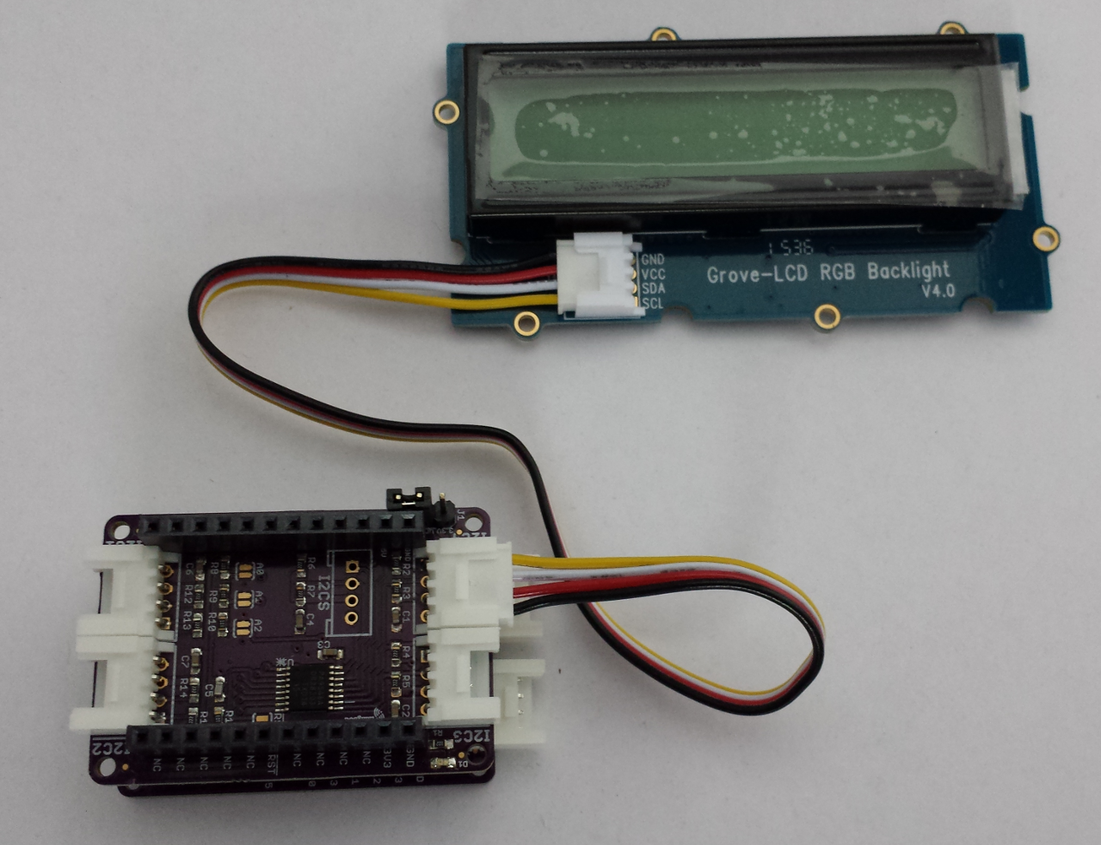

Adding Mikrobus Peripherals :
The TSOC_GROVEY_I2CHUB board supports both Grove and Mikrobus peripherals.
1) Make sure to align the SQUARE/CUT edges of the Mikrobus board together to insure that
the polarity is correct. Push down evenly to seat the boards in the socket.
2) Note that the "stacking pins" are somewhat longer by design, and there will be some
extra space between the boards when using stacking connectors.
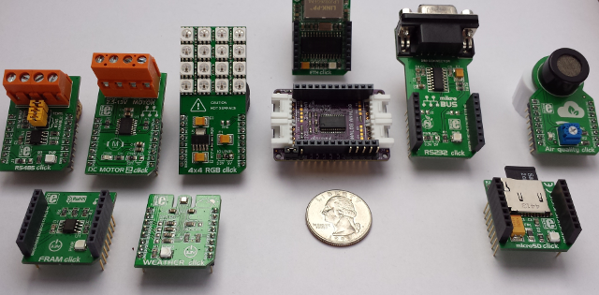
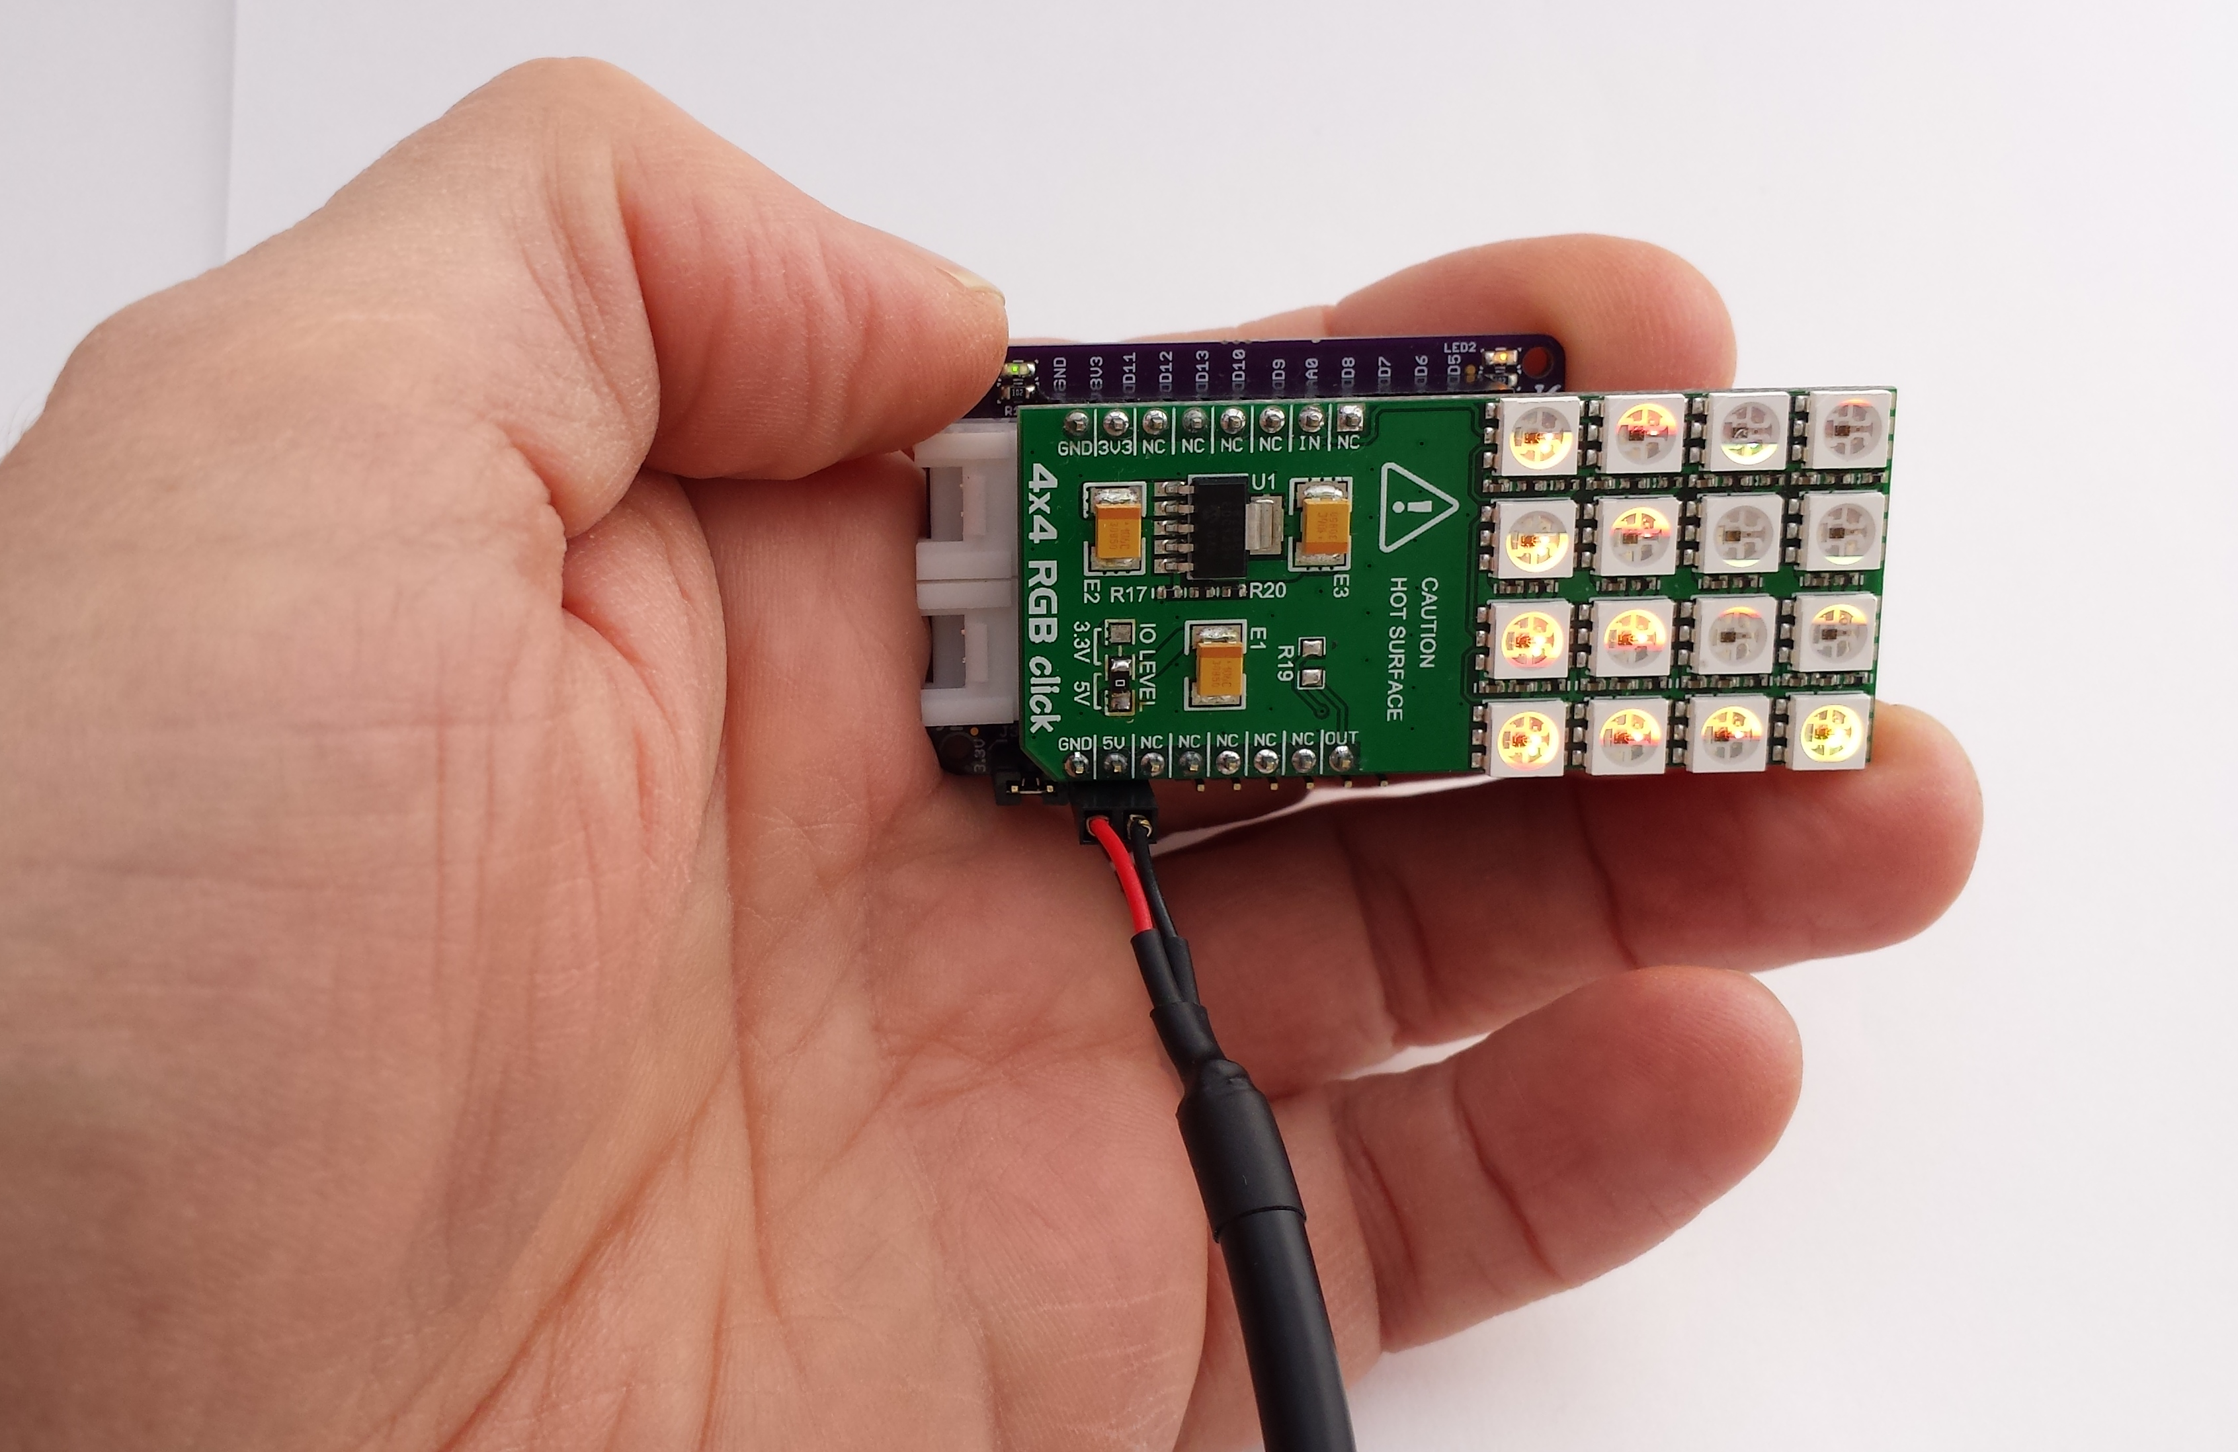

thingSoC® Grovey One Arduino Example :

1) Using Multiple LCD Displays with the TSOC_GROVEY_I2CHUB board
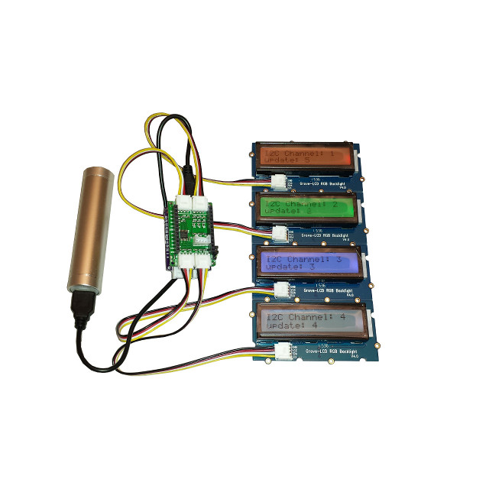

For more information and examples :

Complete documentation, including schematics, layouts, gerbers, and Bill of Materials (BOM) are available on the thingSoC website at :
https://github.com/thingSoC/TSOC_GROVEY_I2CHUB/tree/master/TSOC_GROVEY_I2CHUB

There is also a project Wiki available for asking questions and more information at :
https://github.com/thingSoC/TSOC_GROVEY_I2CHUB/wiki

thingSoC® Grovey One Features :
The TSOC_GROVEY_I2CHUB is a low cost, embeddable module featuring an NXP PCA9546A device :
- NXP PCA9546A
- 0 Hz to 400KHz I2C Bus Speed
- 3.3 Volt or 5.0 Volt operation
- Optional Active Low Reset Line
- All channels deselected on Power up
- No Glitch switching
- Supports hot insertion
- Low Standby current
- Builtin ESD protection
- I2C (4 Channels)
- Power LEDs
- thingSoC Compliant Module
- Mikrobus Compatible Module
- Support SeeedStudio Grove Peripherals



